Minimum Spanning Trees and integration with species distributions to identify priority connectivity corridors
Deliverable 3 - MST results summary
Progress report to the MELCCFP – October 2026
Prepared by:
Andrew Habrich, Carina Rauen Firkowski, Bronwyn Rayfield, Andrew Gonzalez

The Ministère de l’Environnement, de la Lutte contre les changements climatiques, de la Faune et des Parcs (hereafter, MELCCFP) has sought support to identify new terrestrial protected areas to meet the Kunming-Montreal Global Biodiversity Framework target of protecting 30% of its terrestrial territory by the year 2030 as a well-connected ecological network. To achieve this goal, this project conducts a multi-species ecological connectivity assessment to identify conservation priorities for enhancing the network of protected areas in southern Quebec. This will be achieved by the development of a species-specific connectivity assessment based on the integration of movement resistance costed minimum spanning trees (MSTs) and species distribution models (SDMs).
This report presents an overview of the methodology, key decisions and preliminary results of the project. As of October 2026, five of the ten focal species have been analysed (short-eared owl, golden eagle, bobolink, pileated woodpecker and American marten). For each, we present the species-specific MST, report summary statistics of the MST network (Table 2) and maps of the resistance surface, candidate links between protected areas, and the overlap between the MSTs and the species distribution (Figures 3–7).

Methods
Approach: A minimum spanning tree (MST) is the subset of all possible links that connects every node of a network at the lowest total cost without forming loops or backtracking (Prim 1957). When applied to protected areas (PA), it identifies a parsimonious backbone of least-cost corridors that links the whole protected area network (Theobald et al. 2012; Barnett and Belote 2021). Previous applications of MST for protected area design have been species-agnostic (e.g. Bellil et al. 2025); We make this method species-specific by incorporating information on species-specific dispersal ability and habitat requirements to build a separate tree for each focal species.
For each species we:
- Identified the pairs of protected areas within species-specific dispersal range.
- Parameterized landscape resistance to movement based on literature review.
- Computed the accumulated movement cost between each PA pair.
- Extracted the species-specific minimum spanning tree.
- Traced the least-cost path of each tree link between PAs.
- Smoothed the paths to identify relevant movement corridor density.
- Overlaid movement corridor surface with the species’ distribution model.
Figures 1 and 2 illustrate each step for American marten, which is used as the worked example; Figures 3–7 show the main inputs and outputs for each of the five species analysed so far.
Study area and protected areas:
The study area comprised all of Quebec south of 49° N. Analyses were run over a larger modelling extent that also covers adjacent parts of Ontario, New Brunswick, New York, Vermont, New Hampshire and Maine, to encompass ecologically relevant areas to the focal species and to ensure that connections crossing provincial and national borders are not truncated. Protected area polygons from provincial, federal and state registries were merged, large aquatic protected areas were removed, and polygons that overlapped or lay within 50 m of each other were joined into single patches.
For the purposes of analyses, and to capture areas of ecological relevance to the focal species, only patches of at least 5 km² were retained (557 patches, 50,893 km² in total). All distances between patches were measured edge-to-edge, between the nearest points of the two patch boundaries, rather than between centroids, because the PA centroid is not an ecologically meaningful starting point for movement within and between large or irregular patches. With the edge-to-edge linkages, we explicitly assume that there is no cost to movement inside a protected area.
Focal species and dispersal:
Ten focal species spanning a range of taxa, dispersal abilities and habitat associations were selected in workshops with ministry experts. For each species, median natal dispersal distance, dispersal mode and the suitability of each land-cover type, forest type and forest age class were compiled from a literature review (Supplementary Table S1). To date, five species have been analysed: golden eagle (Aquila chrysaetos), short-eared owl (Asio flammeus), bobolink (Dolichonyx oryzivorus), pileated woodpecker (Dryocopus pileatus) and American marten (Martes americana).
The probability of dispersal between two patches was modelled with a negative exponential kernel based on the median dispersal distance estimated from the literature. Pairs of patches with within a distance with a dispersal probability p ≥ 0.05 were retained as candidate links (Figure 1A–B).
Landscape resistance:
Resistance to movement was mapped on a 30 m grid from a harmonized land-cover map (including roads and railways) and from forest type and forest age maps, following the doubling resistance scaling of Albert et al. (2017). Each cell receives an ordinal rank, where 0 is the most suitable, and resistance = 2^{rank}, so each step doubles the cost of crossing a cell. Ranks for land-cover types (deciduous forest, coniferous forests, mixed forests, agriculture, open wetlands, forested wetlands, grassland, shrubland and barren land) whose suitability differs among species came from the species’ suitability ratings (highly suitable = 0, suitable = 2, poorly suitable = 3, unsuitable = 5). Urban areas, roads and railways received high ranks common to all species (between ranks 4–6). The rank for water used a common rank adjusted for species’ dispersal mode. In forest cells, the rank combined the species’ rating of the forest type (coniferous, deciduous or mixed) with a penalty for each age-class away from the species’ preferred forest ages. Resistance therefore ranges from 1 in optimal habitat to 64 in urban areas (Figure 1C; scoring rules in Supplementary Section S3).
Cost distance and minimum spanning tree:
For each candidate pair, accumulated cost distance was computed with the terra package (Hijmans 2026), treating the whole origin patch as the source and taking the lowest accumulated cost over the destination patch. Cost is expressed in cost-weighted distance (resistance × metres); because the lowest resistance is 1, the cost of a link is never less than its straight-line length, and the ratio of the two (the detour factor) is the mean resistance met along the link. Candidate links, weighted by cost distance, formed one graph per species, from which the minimum spanning tree was extracted with Prim’s algorithm (Prim 1957) in the igraph package (Csardi and Nepusz 2006). Where some patches had no candidate partner within dispersal range of the rest of the network, the graph is split into disconnected components and the result is a minimum spanning forest, with one tree per component (Figure 1D).
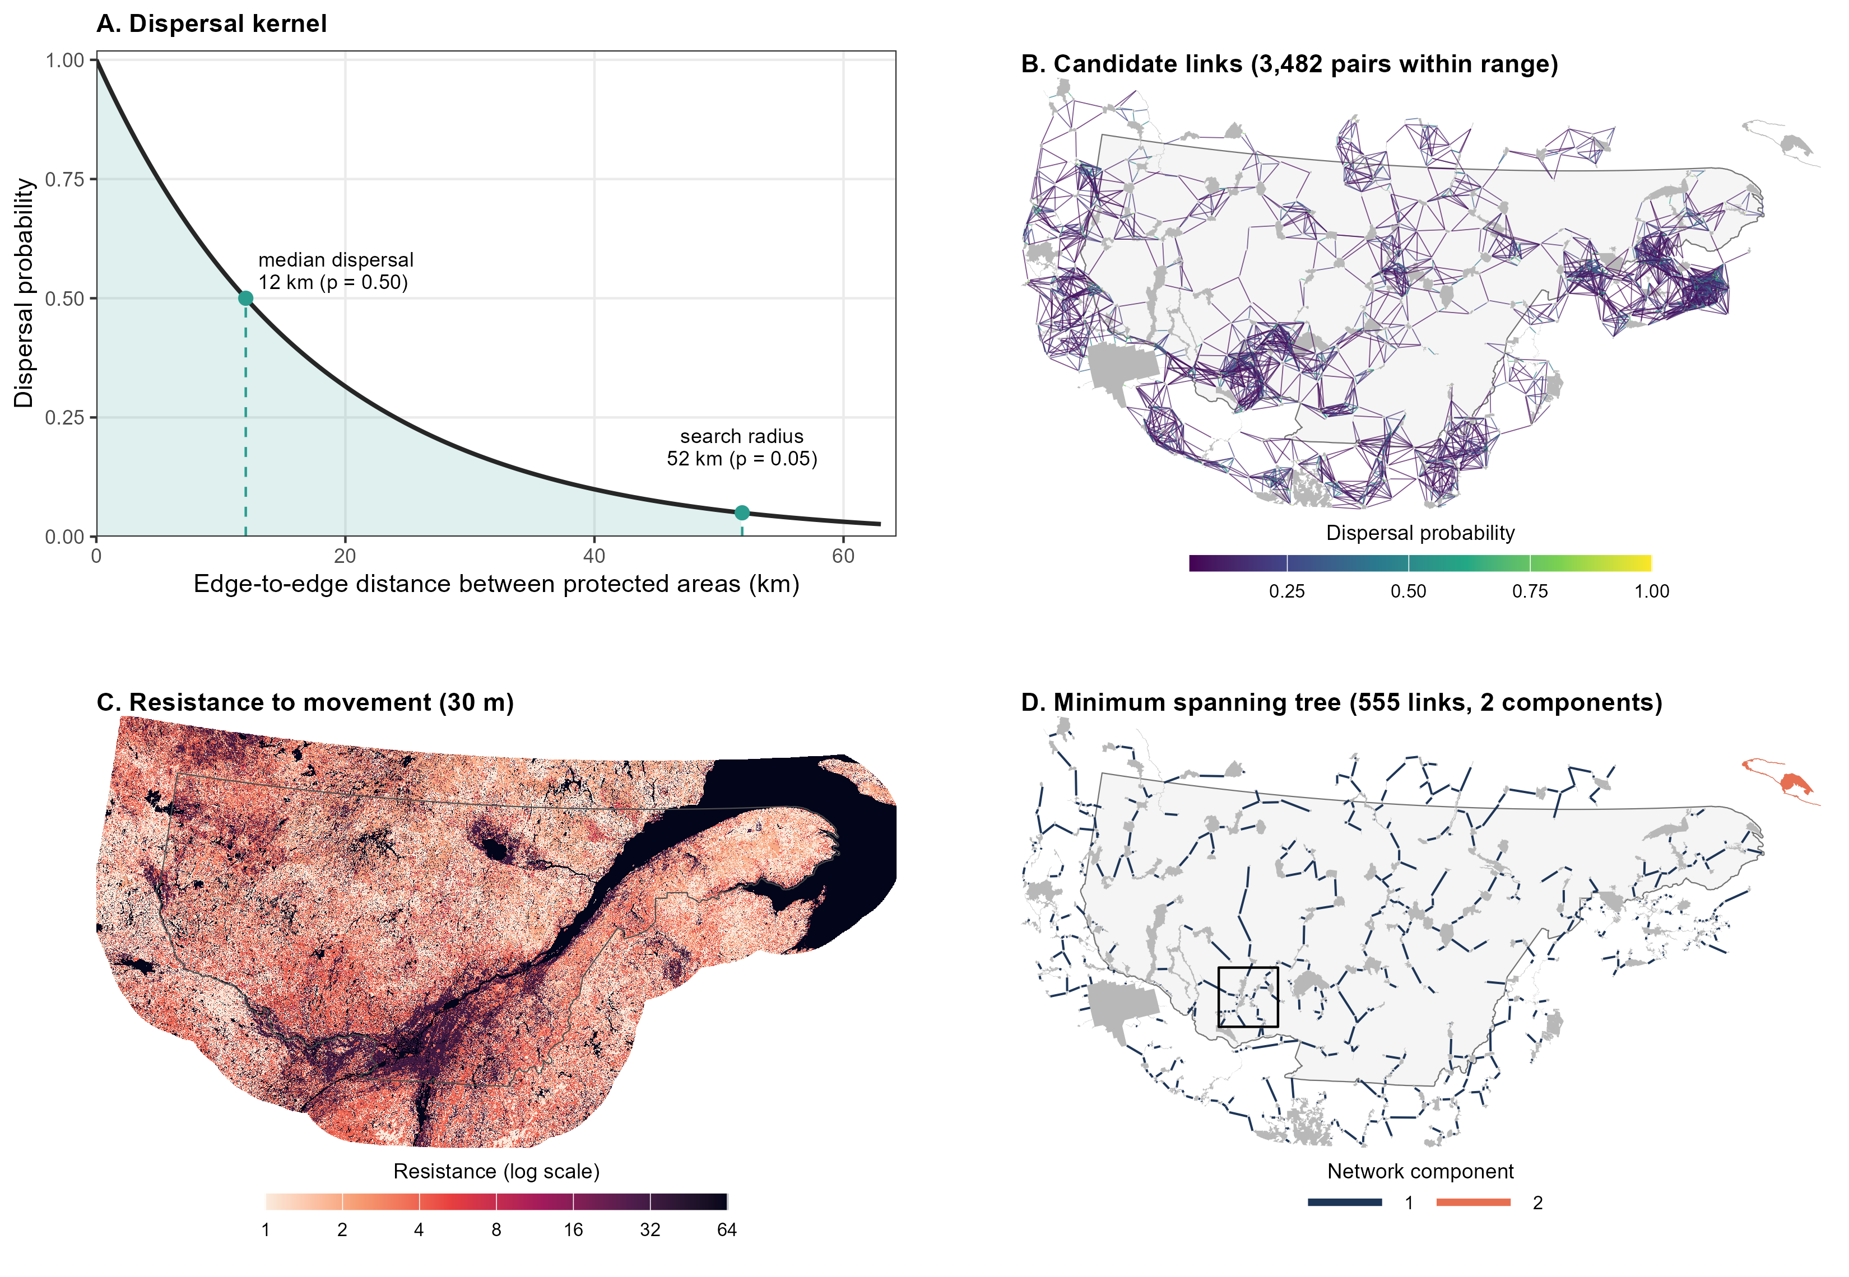
Figure 1. Building the protected-area network for American marten, the worked example. (A) Negative exponential dispersal kernel, with p = 0.5 at the median dispersal distance (12 km); pairs of protected areas closer than the search radius (52 km, p = 0.05) become candidate links. (B) The 3,482 candidate links, drawn edge-to-edge between protected-area boundaries and coloured by dispersal probability. (C) Resistance to movement on the 30 m grid (light = suitable forest; dark = water, urban areas and major roads). (D) Minimum spanning tree selected from the candidate links by cost distance. A small group of protected areas in the far north-east forms a second component (orange). The box marks the window shown in Figure 2. Grey shapes are protected areas (≥ 5 km²); the outline is the study area.
Corridors and integration with species distributions:
Each tree link was traced as a least-cost path between the nearest boundary points of its two patches, across the species’ resistance surface, using the gdistance package (Adriaensen et al. 2003; van Etten 2017; Figure 2A). As dispersers do not follow a single optimal route, the paths were rasterized and smoothed with a Gaussian kernel whose standard deviation equals the mean of the species’ dispersal kernel (D₅₀ / ln 2, with D₅₀ capped at 100 km). This matches the bandwidth used in resistant-kernel connectivity models (Compton et al. 2007) and gives a corridor density surface (length of corridor per unit area) for each species (Figure 2B; Supplementary Figure S1). Corridor density was overlaid with the species distribution models from Eckert et al. (WHAT CITATION?). The lowest 10% of corridor density values were discarded as noise, both surfaces were rescaled to 0–1, and their product identifies areas that are both within dense corridors and likely to be occupied by the species (Figure 2C–D).
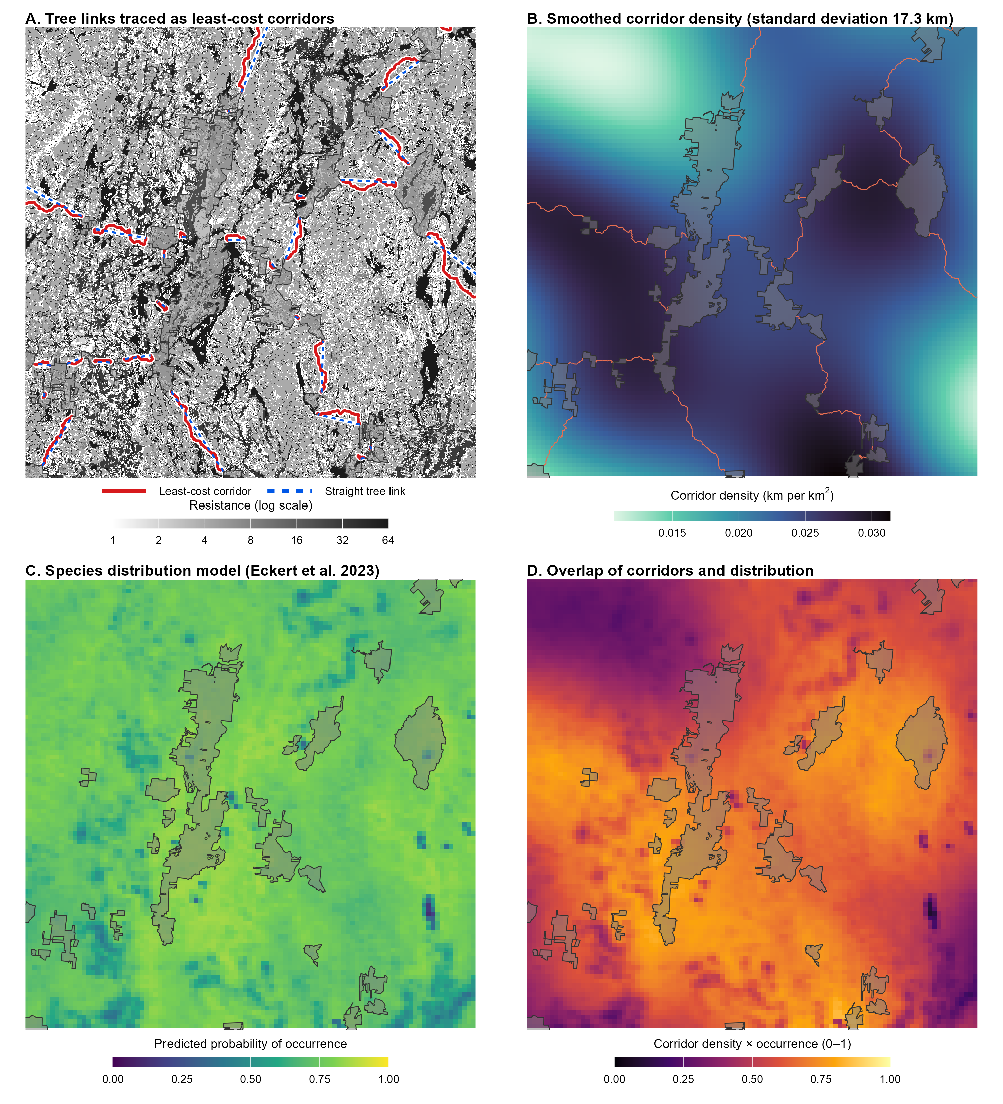
Figure 2. From tree links to corridors and their overlap with the species distribution, shown for a 100 km × 100 km window of the American marten network (box in Figure 1D). (A) Each tree link (dashed blue, straight between the nearest boundary points) is traced as a least-cost corridor (red) across the resistance surface (greyscale; dark = high resistance). (B) Corridors smoothed with a Gaussian kernel (standard deviation 17.3 km) into a corridor density surface. (C) Current predicted probability of occurrence from the species distribution model of Eckert et al. (XXXX). (D) Product of rescaled corridor density and probability of occurrence, after the lowest 10% of corridor density values are removed. Protected areas are shown in transparent grey.
Summary statistics:
For each species we report the number of candidate links, the number of tree links and connected components, the total straight-line length and total cost of the tree, the distribution of link lengths and detour factors, the dispersal probability of tree links (from straight-line distance) and the equivalent connected area (Saura et al. 2011). The equivalent connected area is the size of a single, fully connected protected area that would provide the same probability of connectivity as the network. We calculate it here along the tree links and expressed as a percentage of the total protected area. All analyses were carried out in R (R Core Team 2026) with the sf (Pebesma 2018), terra, igraph and gdistance packages.
Key decisions:
Table 1 summarizes the main decisions taken at each step of the analysis and the reasons for them. Decisions that remain open are listed under Outstanding decisions, after the Results.
Table 1. Key methodological decisions at each step of the analysis.
Step | Decision | Rationale
Protected areas | Merged provincial, federal and state registries; removed large aquatic areas; joined polygons that overlap or lie within 50 m; kept patches ≥ 5 km² (557). | Connections crossing provincial and national borders are not truncated; the size threshold keeps areas of ecological relevance to the focal species.
Distance between protected areas | Edge-to-edge, between the nearest points of the two patch boundaries, rather than between centroids. | Movement inside a protected area is not a connectivity cost, and a centroid is not a meaningful starting point for large or irregular patches.
Candidate links | Negative exponential dispersal kernel with p = 0.5 at the median dispersal distance; pairs kept where p ≥ 0.05 (≈ 4.3 × median distance). | Follows Albert et al. (2017); one probability threshold applied to every species keeps them comparable.
Long-distance dispersers | Where median dispersal exceeds 100 km (short-eared owl), candidates are limited to each patch’s 20 nearest neighbours plus the straight-line spanning tree links. | The search radius would otherwise cover the whole study area; this keeps the network connected while keeping computation feasible.
Landscape resistance | Literature-based suitability ratings converted to ranks, with resistance = 2^{rank}; shared high ranks for urban areas, roads and railways; water adjusted for dispersal mode; forest ranks combine type and age. | Ordinal ratings are the best information available for most species; the doubling scale follows Albert et al. (2017).
Cost distance | Whole origin patch used as the source and lowest accumulated cost taken over the destination patch, on a buffered window around each origin and its candidates. | Consistent with edge-to-edge distances; the full 30 m grid (about 1.1 billion cells) is too large to process at once.
Minimum spanning tree | Prim’s algorithm on candidate links weighted by cost distance; networks that split into components are kept as separate trees, with no links added beyond dispersal range. | Avoids links the species is unlikely to make; joining components is listed as an outstanding decision.
Corridors | Least-cost path between the nearest boundary points of the two patches of each tree link. | Simpler and about half the computation of searching for the cheapest pair of boundary points.
Corridor density | Gaussian smoothing with standard deviation equal to the mean of the dispersal kernel (median ÷ ln 2, median capped at 100 km), on a grid no coarser than 1 km. | Dispersers do not follow a single optimal route; matches the resistant-kernel bandwidth of Compton et al. (2007), and 1 km matches the distribution models.
Overlap with distributions | Current-climate distribution model; lowest 10% of corridor density removed; both surfaces rescaled to 0–1 and multiplied. | Highlights areas that are both within dense corridors and likely to be occupied; the 10% threshold removes the faint tails of the smoothing and has not yet been validated.

Results
Minimum spanning trees have been built for five of the ten focal species (Table 2). Each network spans the same 557 protected areas (50,893 km²). The number of candidate links within dispersal range increased with dispersal distance, from 3,482 for American marten to 21,759 for golden eagle; the short-eared owl had fewer (6,592) because its candidate links were restricted to 20 nearest neighbour patches. The short-eared owl, golden eagle and bobolink networks each formed a single tree. The pileated woodpecker and American marten networks each split into two components: protected areas totalling 1,342 km² (2.6% of the total protected area) had no candidate partner within dispersal range of the rest of the network. These unconnected protected areas are located on Anticosti Island, which is separated from mainland Quebec in the Gulf of the St. Lawrence.
Table 2. Summary of the species-specific minimum spanning trees linking 557 protected areas (≥ 5 km²) in southern Quebec. Species are ordered by decreasing median dispersal distance.
Statistic | Short-eared owl |  | Golden eagle | Bobolink | Pileated woodpecker | American marten
Median dispersal distance (km) |  | 575 | 41 | 19 | 12.35 | 12
Search radius (km)ª |  | 2,485^{b} | 177 | 82 | 53 | 52
Candidate links |  | 6,592 | 21,759 | 6,798 | 3,639 | 3,482
Tree links |  | 556 | 556 | 556 | 555 | 555
Connected components |  | 1 | 1 | 1 | 2 | 2
Protected area in largest component (%) |  | 100 | 100 | 100 | 97.4 | 97.4
Total straight-line length (km) |  | 6,655 | 6,034 | 6,537 | 5,956 | 6,140
Total cost (thousand cost-weighted km)^{c} |  | 52.2 | 18.6 | 98.3 | 12.2 | 18.2
Mean resistance along the tree (total cost / total length) |  | 7.8 | 3.1 | 15.0 | 2.0 | 3.0
Link length, median (quartiles) (km) |  | 7.6 (2.3–15.9) | 7.4 (2.2–15.8) | 7.4 (2.3–16.1) | 7.5 (2.3–15.7) | 7.7 (2.4–16.5)
Longest link (km) |  | 83.5 | 71.5 | 77.9 | 52.8 | 51.1
Detour factor, median (quartiles)^{d} |  | 10.8 (6.5–16.0) | 2.9 (2.2–4.1) | 18.9 (13.3–26.7) | 1.6 (1.3–2.2) | 1.8 (1.4–2.9)
Largest detour factor |  | 74.0 | 21.2 | 74.0 | 20.8 | 67.1
Cost of the most expensive path through the tree (thousand cost-weighted km) |  | 11.1 | 4.7 | 16.0 | 2.5 | 3.8
Link dispersal probability, mean (lowest)^{e} |  | 0.99 (0.90) | 0.85 (0.30) | 0.71 (0.06) | 0.63 (0.05) | 0.61 (0.05)
Equivalent connected area, km² (% of protected area)^{f} |  | 38,699 (76.0) | 17,042 (33.5) | 13,174 (25.9) | 13,337 (26.2) | 13,178 (25.9)
ª Edge-to-edge distance at which dispersal probability falls to 0.05 (≈ 4.3 × median dispersal distance). ^{b} Short-eared owl candidate links were restricted to each protected area’s 20 nearest neighbours plus the straight-line spanning tree links. ^{c} Cost-weighted distance = resistance × distance; 1 cost-weighted km equals 1 km through optimal habitat. ^{d} Cost distance divided by straight-line length of a link (1 = optimal habitat throughout). ^{e} From the straight-line edge-to-edge length of each link; links below 0.05 were excluded. ^{f} Calculated along tree links; with no links at all the value would be 18.6% of protected area.
The total straight-line length of the trees varied little among species, from 5,956 km for pileated woodpecker to 6,655 km for short-eared owl. Every tree connects the same protected areas and favours short links: median link length was 7.4–7.7 km for all species, and the longest single link ranged from 51 km (American marten) to 84 km (short-eared owl). In contrast, total movement cost varied eight-fold, from 12.2 thousand cost-weighted km for pileated woodpecker to 98.3 thousand for bobolink. Dividing total cost by total length gives the mean resistance encountered along the tree. This was 2.0–3.1 for the three species for which forest is suitable habitat (pileated woodpecker, American marten and golden eagle), compared with 7.8 for short-eared owl and 15.0 for bobolink, two open-habitat species for which the forest that dominates the study area is poorly suitable or unsuitable. Median detour factors showed the same contrast (1.6–2.9 compared with 10.8–18.9). Within a species, detour factors vary spatially. For American marten, three quarters of the links have a detour factor below 2.9, and the 45 links above 10 lies mostly in the south of the study area, where agriculture, roads and urban areas are concentrated (Figure 7C; compare Figure 7A). The five trees share much of the same backbone of short links, but detour factors are consistently higher for bobolink and short-eared owl, both of which have specific habitat requirements for grasslands, which are less abundant in the study area compared to forests (panel C of Figures 3–7).
The mean dispersal probability of tree links ranged from 0.61 (American marten) to 0.99 (short-eared owl). For bobolink, pileated woodpecker and American marten the weakest link (probability 0.05–0.06) lies at the dispersal cutoff, so each of these trees depends on at least one link at the limit of the species’ dispersal range. The weakest golden eagle and short-eared owl links had probabilities of 0.30 and 0.90. The equivalent connected area was 25.9–33.5% of the total protected area for the four species with median dispersal distances of 12–41 km, and 76.0% for short-eared owl, compared with 18.6% if no links existed.
Least-cost corridors, corridor density surfaces and overlap surfaces combining corridor density with the species distribution model were produced for all five species. For American marten, the overlap surface is highest in a limited number of regions where several corridors converge in areas of high predicted occurrence, and it falls to near zero across the St. Lawrence River and in gaps between corridors (Figure 7D). For short-eared owl and golden eagle, whose smoothing widths are largest (144 and 59 km), the overlap surface is broad and mostly follows the distribution model (Figures 3D and 4D).
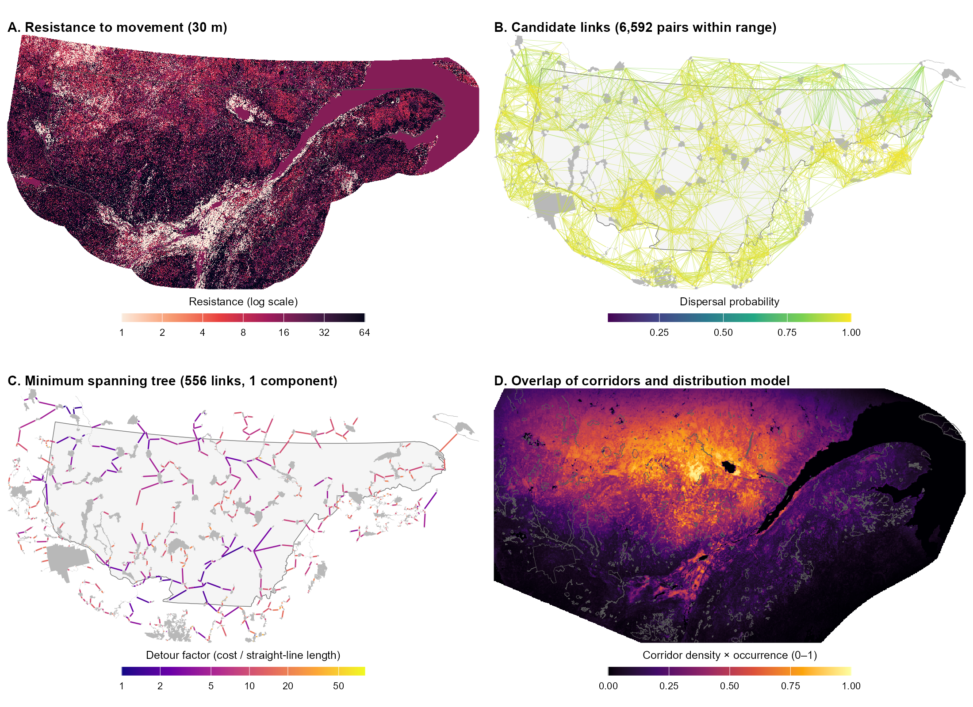
Figure 3. Short-eared owl (median dispersal 575 km). (A) Resistance to movement on the 30 m grid (log scale); open habitats (agriculture, grassland, open wetland) are least resistant and deciduous and mixed forest highly resistant. (B) The 6,592 candidate links, coloured by dispersal probability; because the search radius (2,485 km) exceeds the study area, candidates are each protected area’s 20 nearest neighbours plus the straight-line spanning tree links. (C) Minimum spanning tree (556 links, one component), with links coloured by detour factor (cost distance ÷ straight-line length; log scale). (D) Product of rescaled corridor density (smoothing standard deviation 144 km) and predicted probability of occurrence (0–1); with such wide smoothing the surface mostly follows the distribution model, with the highest values north of the St. Lawrence River in the centre of the study area. Grey shapes are protected areas; the outline is the study area.
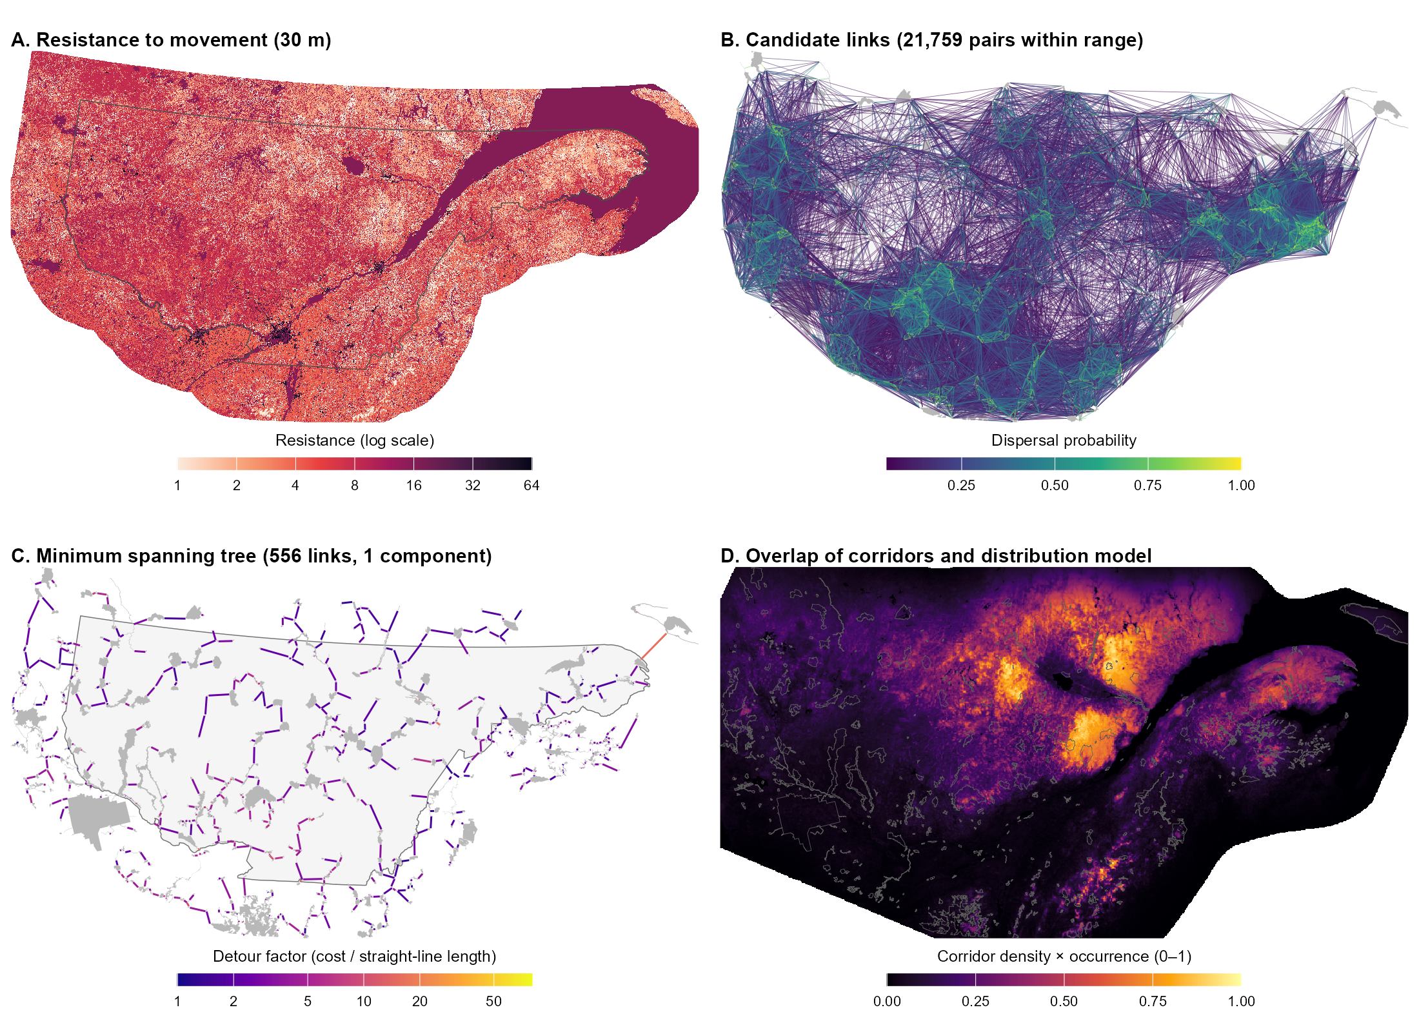
Figure 4. Golden eagle (median dispersal 41 km). (A) Resistance to movement on the 30 m grid (log scale); grassland, barren land and coniferous forest are least resistant, and urban areas and major roads most resistant. (B) The 21,759 candidate links within the 177 km search radius, coloured by dispersal probability. (C) Minimum spanning tree (556 links, one component), with links coloured by detour factor (log scale). (D) Product of rescaled corridor density (smoothing standard deviation 59.2 km) and predicted probability of occurrence (0–1), highest north of the St. Lawrence estuary around Lac Saint-Jean. Grey shapes are protected areas; the outline is the study area.
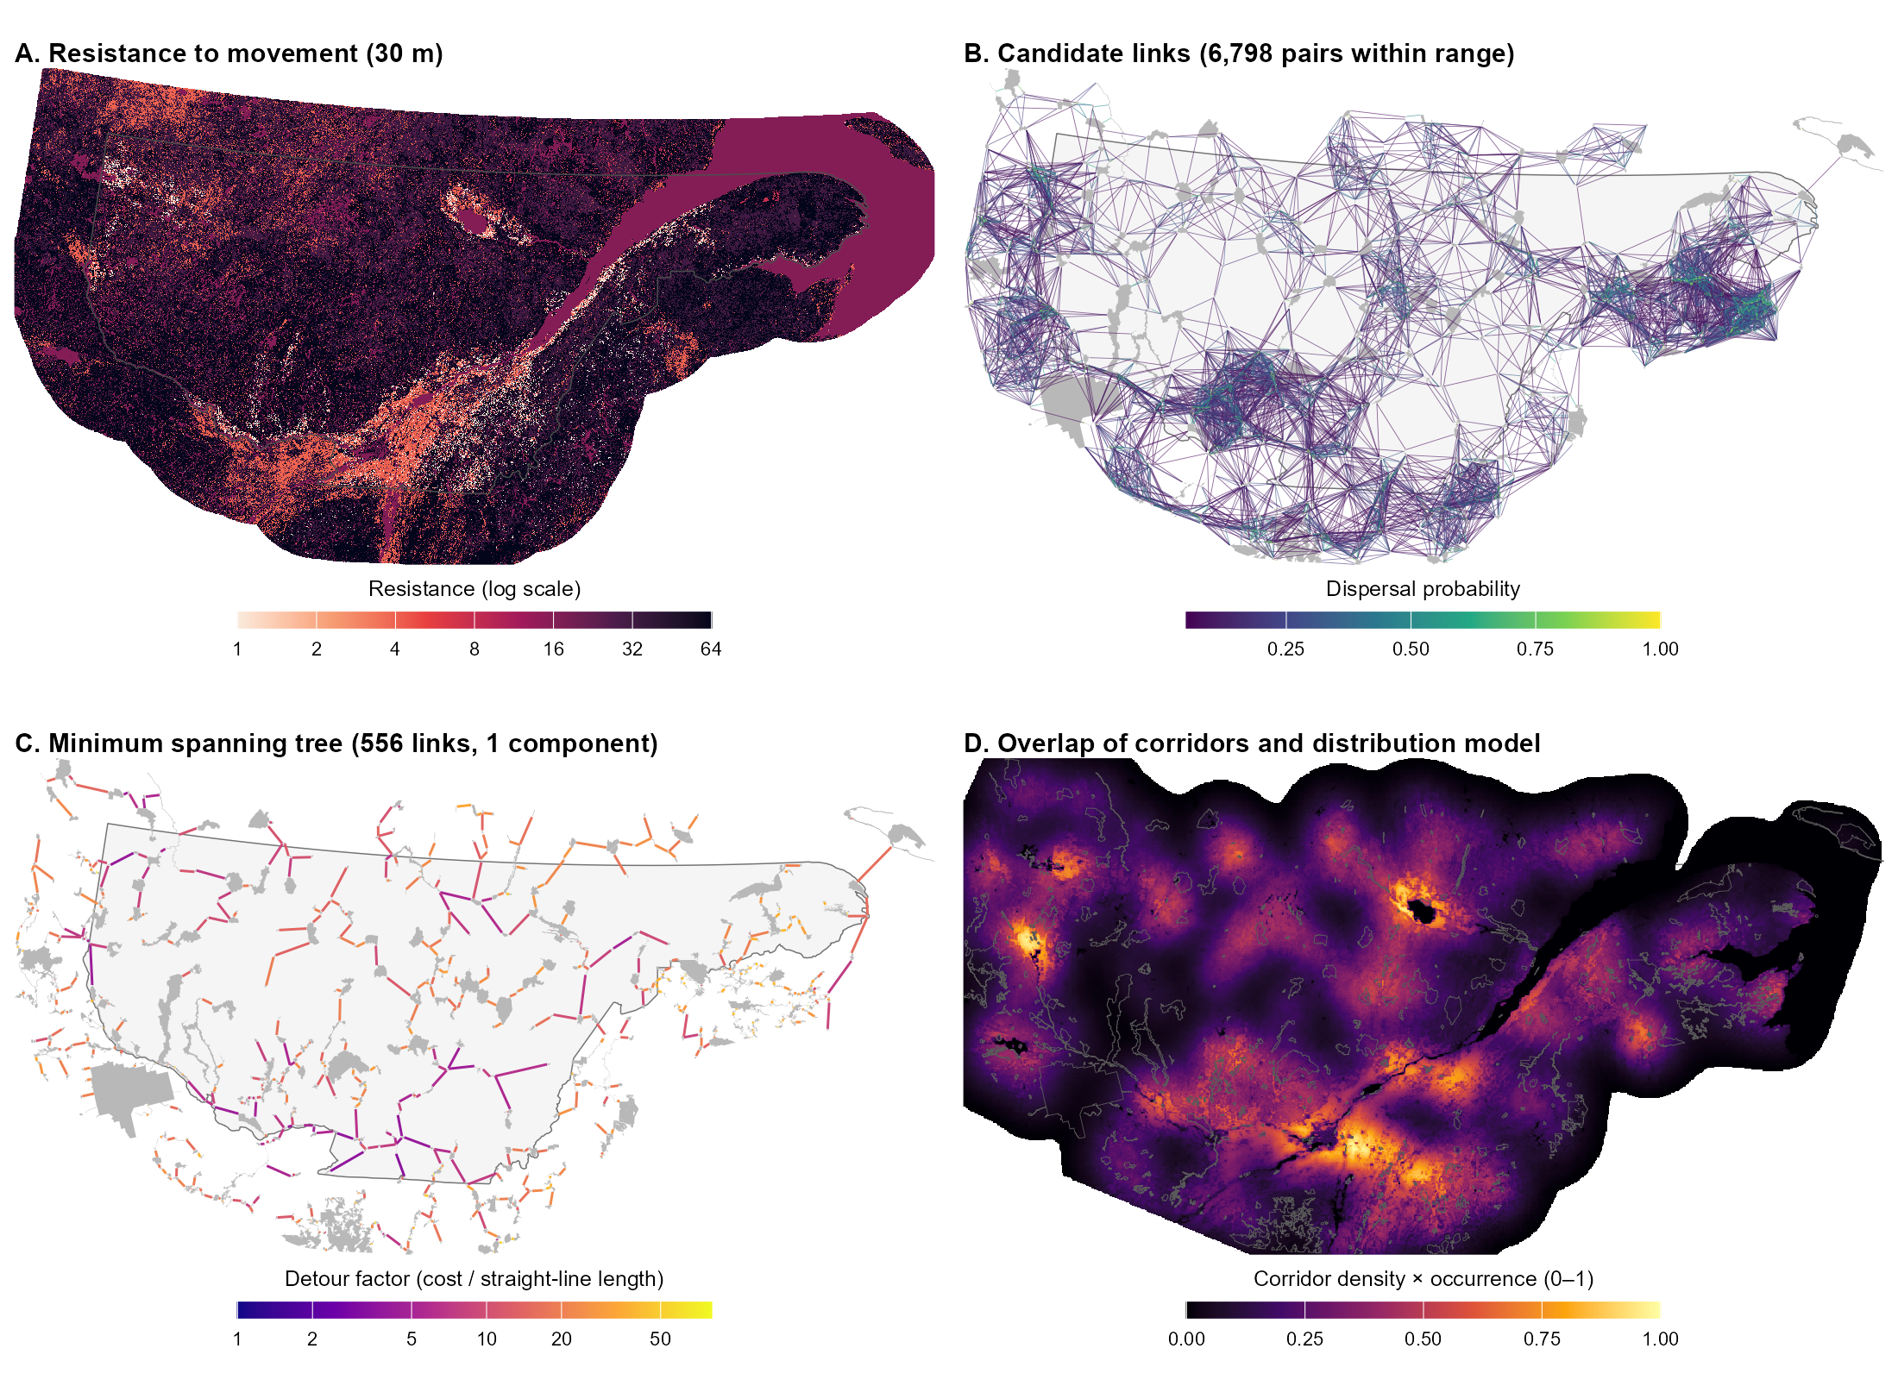
Figure 5. Bobolink (median dispersal 19 km). (A) Resistance to movement on the 30 m grid (log scale); grassland is least resistant, agriculture and open wetland moderately resistant, and all forest types highly resistant. (B) The 6,798 candidate links within the 82 km search radius, coloured by dispersal probability. (C) Minimum spanning tree (556 links, one component), with links coloured by detour factor (log scale); detour factors are high throughout because most links cross forest. (D) Product of rescaled corridor density (smoothing standard deviation 27.4 km) and predicted probability of occurrence (0–1), highest in the agricultural St. Lawrence lowlands and around Lac Saint-Jean. Grey shapes are protected areas; the outline is the study area.
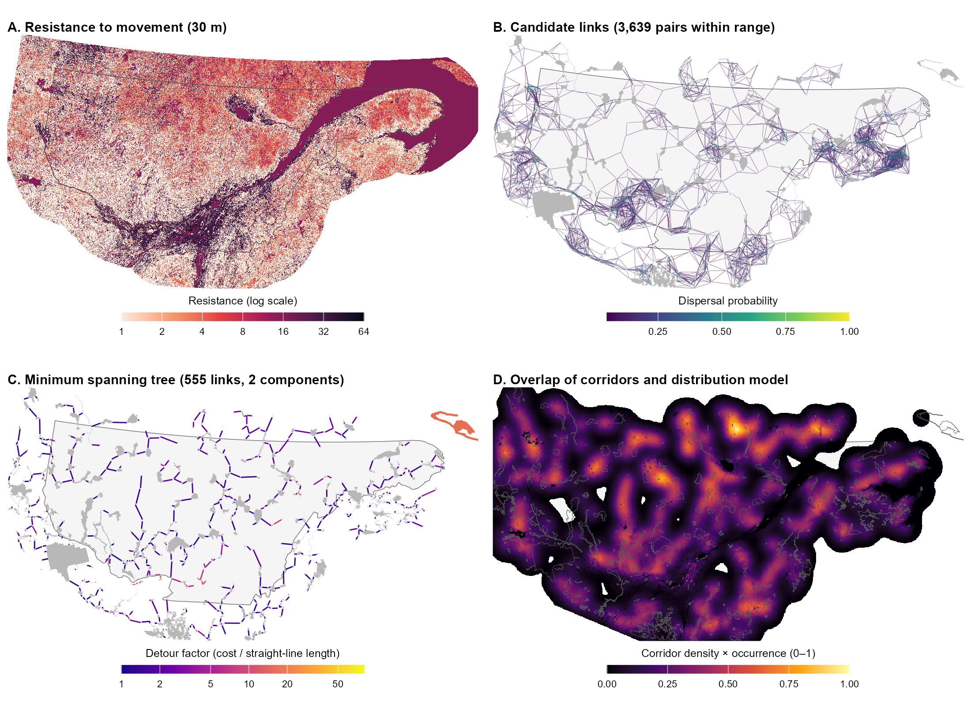
Figure 6. Pileated woodpecker (median dispersal 12.35 km). (A) Resistance to movement on the 30 m grid (log scale); deciduous and mixed forest and forested wetland are least resistant, and open land (agriculture, grassland, open wetland) highly resistant, so the agricultural St. Lawrence lowlands are costly to cross. (B) The 3,639 candidate links within the 53 km search radius, coloured by dispersal probability. (C) Minimum spanning tree (555 links, two components), with links coloured by detour factor (log scale); protected areas of the second component, on Anticosti Island, are shown in orange. (D) Product of rescaled corridor density (smoothing standard deviation 17.8 km) and predicted probability of occurrence (0–1), which follows the corridor network across the forested parts of the study area and is lower in the St. Lawrence lowlands. Grey shapes are protected areas; the outline is the study area.
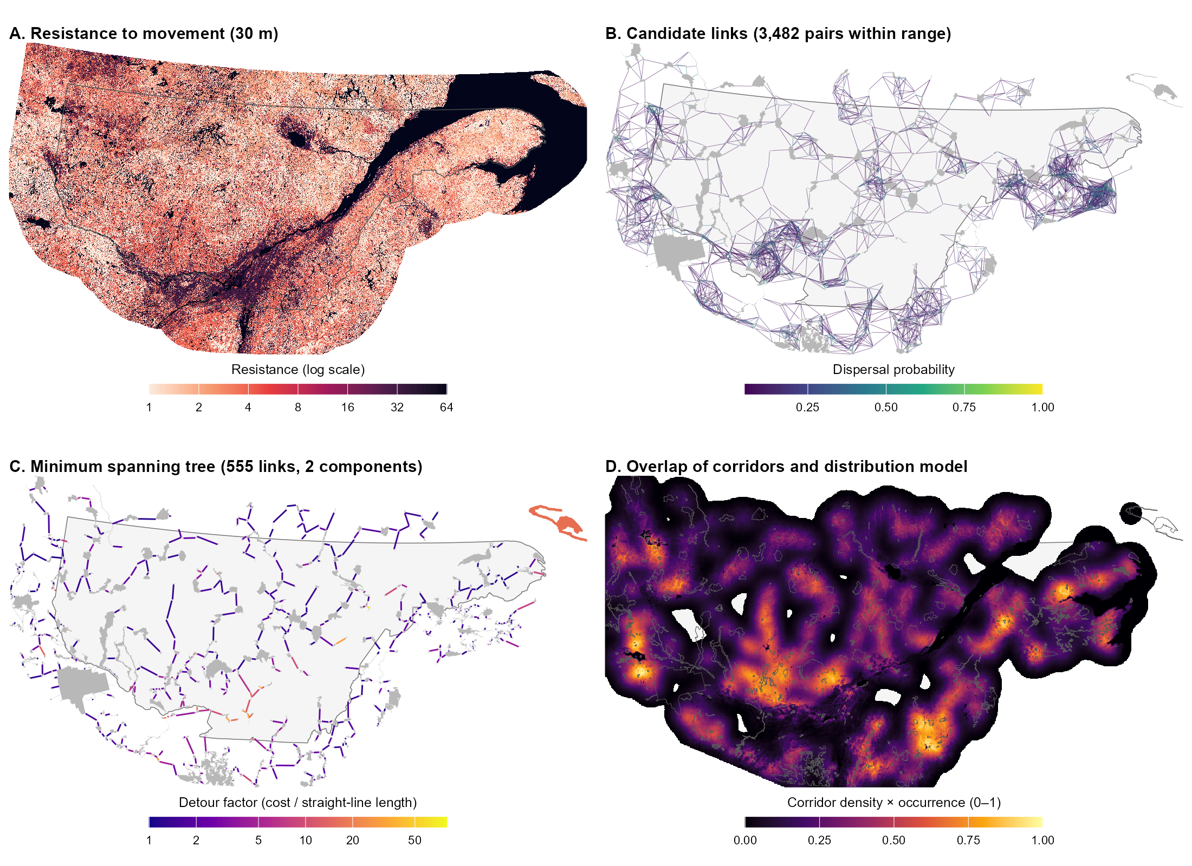
Figure 7. American marten (median dispersal 12 km). (A) Resistance to movement on the 30 m grid (log scale); coniferous and mixed forest are least resistant, and open land, urban areas, major roads and water most resistant. (B) The 3,482 candidate links within the 52 km search radius, coloured by dispersal probability. (C) Minimum spanning tree (555 links, two components), with links coloured by detour factor (log scale); the highest detour factors lie mostly in the south of the study area, where agriculture, roads and urban areas are concentrated, and protected areas of the second component, on Anticosti Island, are shown in orange. (D) Product of rescaled corridor density (smoothing standard deviation 17.3 km) and predicted probability of occurrence (0–1), highest where several corridors converge in areas of high predicted occurrence and near zero across the St. Lawrence River and in gaps between corridors. Grey shapes are protected areas; the outline is the study area.

Outstanding decisions
The following decisions affect the results above and would benefit from discussion with the ministry before the remaining species are run.
- Dispersal cutoff: the cutoff for candidate links is applied to straight-line edge-to-edge distance rather than to cost distance, so link probabilities and the equivalent connected area do not respond to landscape resistance.
- Disconnected networks: the pileated woodpecker and American marten networks each have a second component on Anticosti Island. These could be joined by adding the cheapest link between components, flagged as exceeding the dispersal kernel.
- Canada lynx: its median dispersal distance (100 km) falls exactly at the threshold for limiting candidate links, so it is not limited and its search radius is about 432 km. The threshold should be confirmed before lynx is run.
- Wetland ratings: the open and forested wetland ratings for each species were initially copied from a single wetland rating and await species-by-species review.
- Wood turtle: no distribution model is available, so this species will receive a corridor density surface only.
- Overlap threshold: the 10% of lowest corridor density values removed before the overlap step should be checked against the data.

Next steps
The next stages of the project are:
- Run the remaining five focal species (Canada lynx, beaver, wood turtle, eastern red-backed salamander and southern red-backed vole) through the same analysis once the outstanding decisions are settled.
- Task 6: overlay the integrated networks with protection status to evaluate how much of each species’ corridors and overlap hotspots is protected, and how this changes under alternative protected-area scenarios.
- Task 7: synthesize the methods and results in a final English report with high-resolution figures, and archive the data and scripts.

References
Adriaensen, F., Chardon, J.P., De Blust, G., Swinnen, E., Villalba, S., Gulinck, H. and Matthysen, E. (2003). The application of ‘least-cost’ modelling as a functional landscape model. Landscape and Urban Planning, 64, 233–247.
Albert, C.H., Rayfield, B., Dumitru, M. and Gonzalez, A. (2017). Applying network theory to prioritize multispecies habitat networks that are robust to climate and land-use change. Conservation Biology, 31, 1383–1396. https://doi.org/10.1111/cobi.12943
Barnett, K. and Belote, R.T. (2021). Modeling an aspirational connected network of protected areas across North America. Ecological Applications, 31, e02387. https://doi.org/10.1002/eap.2387
Bellil A et al. 2025. Using landscape graphs to assess the ecological relevance of biodiversity conservation plans for forest habitat networks. Land Use Policy. 158:107740. https://doi.org/10.1016/j.landusepol.2025.107740
Compton, B.W., McGarigal, K., Cushman, S.A. and Gamble, L.R. (2007). A resistant-kernel model of connectivity for amphibians that breed in vernal pools. Conservation Biology, 21, 788–799.
Csardi, G. and Nepusz, T. (2006). The igraph software package for complex network research. InterJournal, Complex Systems, 1695.
Eckert et al. XXXX WHAT CITATION
Environment and Climate Change Canada (2025). Canadian Protected and Conserved Areas Database. Government of Canada, Gatineau, Quebec.
Hijmans, R.J. (2026). terra: Spatial Data Analysis. R package version 1.9-50.
Pebesma, E. (2018). Simple features for R: standardized support for spatial vector data. The R Journal, 10, 439–446.
Prim, R.C. (1957). Shortest connection networks and some generalizations. Bell System Technical Journal, 36, 1389–1401.
R Core Team (2026). R: A Language and Environment for Statistical Computing, version 4.6.1. R Foundation for Statistical Computing, Vienna, Austria.
Saura, S., Estreguil, C., Mouton, C. and Rodríguez-Freire, M. (2011). Network analysis to assess landscape connectivity trends: application to European forests (1990–2000). Ecological Indicators, 11, 407–416.
Theobald, D.M., Reed, S.E., Fields, K. and Soulé, M. (2012). Connecting natural landscapes using a landscape permeability model to prioritize conservation activities in the United States. Conservation Letters, 5, 123–133.
U.S. Geological Survey Gap Analysis Project (2024). Protected Areas Database of the United States (PAD-US) 4.1. U.S. Geological Survey data release. https://doi.org/10.5066/P96WBCHS
van Etten, J. (2017). R package gdistance: distances and routes on geographical grids. Journal of Statistical Software, 76(13), 1–21.
Supplementary information
S1. Focal species
Species traits are maintained in the “top10” sheet of specieslist.xlsx, with sources in its literature review sheets. Search radius and smoothing standard deviation follow from the median dispersal distance (Supplementary Sections S2 and S4). Four-letter codes are used as file-name prefixes for every output.
Table S1. Focal species, dispersal parameters and analysis status.
Code | Common name | Scientific name | Dispersal mode | Median dispersal (km) | Search radius (km) | Smoothing standard deviation (km) | Distribution model | Status
ASFL | Short-eared owl | Asio flammeus | Flying | 575 | 2,485 | 144.3ª | Yes | Analysed
AQCH | Golden eagle | Aquila chrysaetos | Flying | 41 | 177 | 59.2 | Yes | Analysed
DOOR | Bobolink | Dolichonyx oryzivorus | Flying | 19 | 82 | 27.4 | Yes | Analysed
DRPI | Pileated woodpecker | Dryocopus pileatus | Flying | 12.35 | 53 | 17.8 | Yes | Analysed
MAAM | American marten | Martes americana | Fossorial | 12 | 52 | 17.3 | Yes | Analysed
LYCA | Canada lynx | Lynx canadensis | Terrestrial | 100 | 432 | 144.3 | Yes | Pending
CSCA | Beaver | Castor canadensis | Aquatic | 9.075 | 39 | 13.1 | Yes | Pending
GLIN | Wood turtle | Glyptemys insculpta | Aquatic | 0.219 | 0.95 | 0.32 | No | Pending
PLCI | Eastern red-backed salamander | Plethodon cinereus | Fossorial | 0.09 | 0.39 | 0.13 | Yes | Pending
CLGA | Southern red-backed vole | Clethrionomys gapperi | Fossorial | 0.03 | 0.13 | 0.06^{b} | Yes | Pending
ª Median dispersal capped at 100 km for smoothing. ^{b} Floored at two grid cells (60 m).
S2. Protected areas and candidate links
Protected-area sources were the Quebec register of protected areas and the Canadian Protected and Conserved Areas Database (terrestrial areas only; Environment and Climate Change Canada 2025), Ontario federal protected areas and regulated provincial parks, New Brunswick wildlife refuges, Nature Legacy protected areas and protected natural areas, and the Protected Areas Database of the United States 4.1 for New York, Vermont, New Hampshire and Maine (U.S. Geological Survey Gap Analysis Project 2024). Nineteen large aquatic protected areas were removed by identifier. Overlapping polygons were dissolved, and polygons within 50 m of each other were joined by buffering outward and back by 50 m. A 10 km² subset was also produced, but all analyses so far use the 5 km² set. Boundaries were simplified with a 30 m tolerance (topology preserved). All layers use the NAD83 / Quebec Lambert projection (EPSG:32198).
The kernel parameter is α = ln 2 / D₅₀, and the search radius is −ln(0.05) / α ≈ 4.32 × D₅₀. Candidate pairs were first screened with a spatial index (sf::st_is_within_distance) and exact edge-to-edge distances were then computed only for the retained pairs. Species with D₅₀ > 100 km (currently the short-eared owl only) are sparsified to each patch’s 20 nearest partners plus the edges of the straight-line minimum spanning tree. The same dispersal cutoff is re-applied, on straight-line distance, before the tree is built.
S3. Resistance scoring
Ranks are converted to resistance as 2^{rank}. Suitability tiers map to ranks as follows: highly suitable 0, suitable 2, poorly suitable 3, unsuitable 5. Fixed ranks common to all species are urban 6, major roads 6, railways 6, minor roads 5, forestry roads class A 5, and forestry roads classes B and C 4. Flying species receive −1 on all road and railway ranks. Water starts at rank 5 and is adjusted by dispersal mode: −1 for flying and aquatic species, +1 for fossorial species, unchanged for terrestrial species (floored at 0).
Forest cells take the species’ forest-type rank (coniferous, deciduous or mixed) plus an age penalty. The penalty is the number of ordinal steps (young → mature → old) between the cell’s age class and the nearest age class the species prefers (0–3). The two intermediate age classes count as mature. Uneven-aged stands score 0 for species preferring young or old forest, and 1 for species preferring mature forest only. For forest types the species rates unsuitable, the age penalty is capped at +1, so unsuitable forest reaches at most rank 6, the same as urban areas. Forest cells with missing type or age data use the rounded mean of the species’ three forest-type ranks. Wetlands are split into open and forested classes, each rated separately per species.
Table S2. Resistance values (2^{rank}) by land-cover class for the five analysed species. Forest values exclude the age penalty, which multiplies resistance by 2 per age-class step.
Land-cover class | Short-eared owl | Golden eagle | Bobolink | Pileated woodpecker | American marten
Agriculture | 1 | 4 | 4 | 32 | 32
Wetland, open | 1 | 8 | 4 | 32 | 32
Wetland, forested | 8 | 8 | 32 | 1 | 4
Grassland | 1 | 1 | 1 | 32 | 32
Barren and shrubland | 1 | 1 | 8 | 32 | 32
Coniferous forest | 8 | 1 | 32 | 4 | 1
Deciduous forest | 32 | 4 | 32 | 1 | 4
Mixed forest | 32 | 4 | 32 | 1 | 1
Forest, type or age missing | 16 | 2 | 32 | 2 | 2
Water | 16 | 16 | 16 | 16 | 64
Urban | 64 | 64 | 64 | 64 | 64
Major roads and railways | 32 | 32 | 32 | 32 | 64
Minor roads, forestry roads A | 16 | 16 | 16 | 16 | 32
Forestry roads B and C | 8 | 8 | 8 | 8 | 16
S4. Cost distance, corridors and overlap
Cost distance was computed once per origin patch with terra::costDist on the resistance raster cropped to the origin and its candidate destinations, buffered by the larger of 25% of the longest pair distance or 1 km. Every cell of the origin polygon is a zero-cost source, and each destination’s cost is the minimum accumulated cost over its own polygon. If a destination was unreachable, the origin was retried once with a doubled buffer. Pairs still without a cost were dropped. Tree edges are also saved as straight boundary-to-boundary lines for mapping.
Least-cost paths were traced with gdistance (conductance = 1 / mean resistance of neighbouring cells) between the geometrically nearest points of the two patch boundaries. The resistance raster was cropped per link to a buffer of 25% of the link length (between 1 and 5 km), with one retry at double the buffer. For corridor density, each path was rasterized and smoothed per link on a species-specific grid (resolution ≈ smoothing standard deviation / 10, a multiple of 30 m and at most 1 km), with the crop padded by three standard deviations, and the links were summed. A combined multi-species density map was built on a common 1 km grid, with each species normalized to its own maximum before summing so that no species dominates. Distribution models (Eckert et al. 2023) are continent-wide; only the current-climate layer was used. It was cropped to the modelling extent plus 10 km, reprojected at its native ~1 km resolution, and missing values were set to 0. In the overlap step, the lowest 10% of corridor density values were removed, corridor density and the distribution model were each rescaled to 0–1, and the two were multiplied.
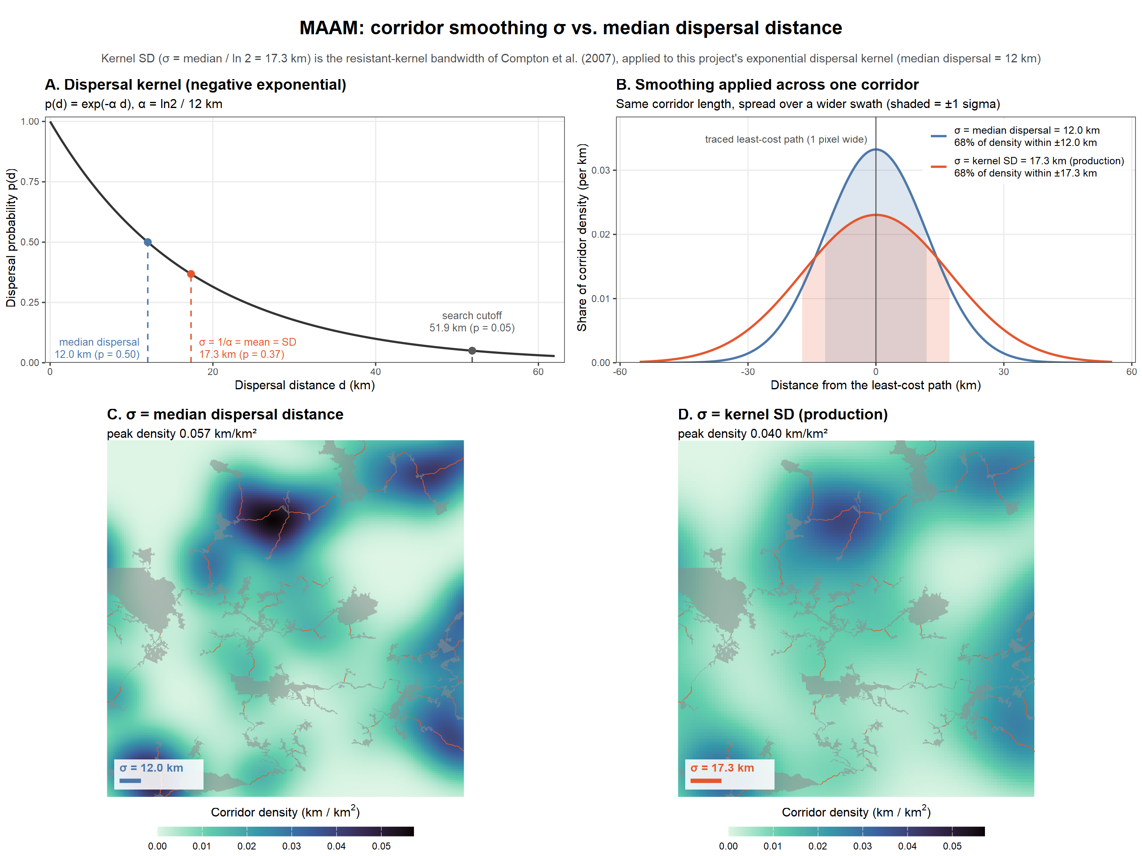
Figure S1. Choice of the corridor smoothing width, shown for American marten. (A) Dispersal kernel with the median dispersal distance, the kernel’s mean (= standard deviation, used as the smoothing width) and the search radius marked. (B) Cross-section of the Gaussian smoothing applied to one corridor with each width. (C–D) The species’ traced corridors in its densest 200 km window, smoothed with the median dispersal distance (C) and with the kernel standard deviation used in the analysis (D), on a common colour scale. Labels use σ for the smoothing standard deviation.
Deliverables
File paths are relative to the project folder. [sp] denotes the four-letter species code (Table S1).
Table D1. Deliverables and associated files.
Deliverable | Files | Status
Harmonized protected areas | data/intermediate/00_PAs/pa_model_5km2.shp, pa_model_10km2.shp; data/output_data/01_PA_patches/pa_patches.gpkg, pa_ctroidnodes.shp | Complete
Species traits and dispersal parameters | data/drive_data/specieslist.xlsx (“top10” sheet); data/drive_data/species_metadata.csv; data/drive_data/suitability/[sp]_landcover_rank.csv, [sp]_forest_type_rank.csv, [sp]_age_penalty.csv; output/tables/01_dispersal_kernel_params.csv | Traits for 10 species; dispersal table for 5
Candidate protected-area pairs | data/intermediate/01_PA_candidates/[sp]_PApairs_dkernel_cutoff.csv, [sp]_PApairs_edge_lines.gpkg | 5 species
Resistance surfaces (30 m) | data/output_data/02_resistance/[sp]_res.tif; output/tables/02_landcover_resistance_by_species.csv | 5 species
Pairwise cost distances | data/intermediate/03_cost_distances/[sp]_PA_costs.csv | 5 species
Minimum spanning tree maps and summary tables | data/output_data/04_mst/[sp]_mst_lines.gpkg; data/intermediate/04_mst/[sp]_mst_edges.csv, [sp]_mst.rds; output/tables/04_mst_summary.csv, 04_mst_edge_stats.csv | 5 species
Least-cost corridors | data/intermediate/05_lcp_corridors/[sp]_lcp_corridors.gpkg | 5 species
Corridor density maps | data/intermediate/06_corridor_density/[sp]_corridor_density.tif, all_species_corridor_density.tif | 5 species
Corridors integrated with species distributions | data/output_data/07_mst_SDM_overlap/[sp]_habitat_overlap.tif | 5 species
Report figures | output/figures/report_fig1_network_MAAM.png, report_fig2_corridors_MAAM.png, deliverable3_maps_[sp].png, MAAM_corridor_sigma_vs_median.png; scripts/misc scripts/fig_results_document.R, fig_deliverable3.R, fig_corridor_sigma_vs_median.R | Current
Code and documentation | scripts/ (setup_script.R, pipeline_functions.R, setup_species_from_xlsx.R, scripts 00–07); MST script workflow document.docx; Deliverable 3 - MST results summary.docx | Current

